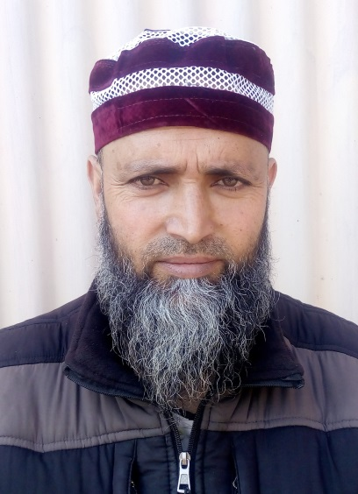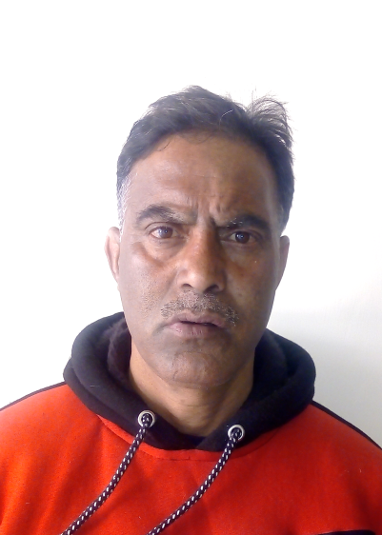

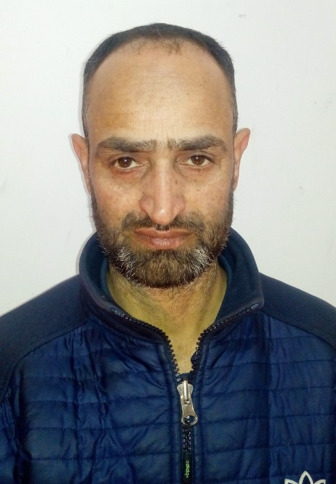

Mr. Ab Rashid Alie

Lab Attendant

Office Orderly

Contact No. 7051557646

Mr. Gh. Jeelani Dar

Lab Attendant

Foundry Lab

Contact No. 7051227945

Mr. Bashir Ahmad Baba

Lab Attendant

Foundry Lab

Contact No. 7889316823

Mr. Mushtaq Ahmad Sheikh

Lab Attendant

Computer Lab

Contact No. 6005777563

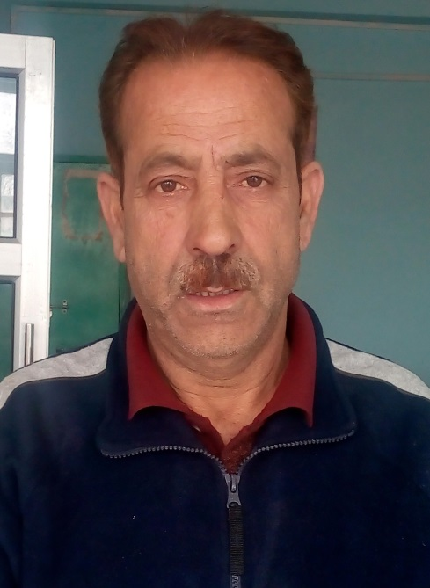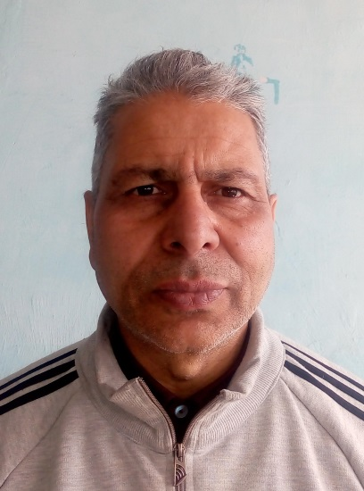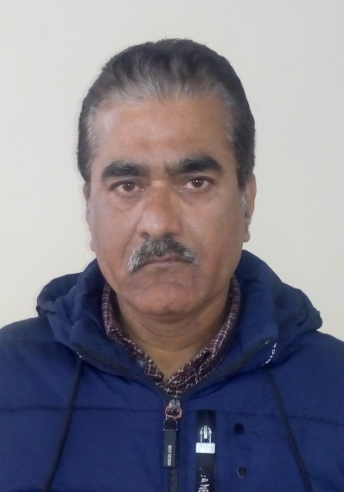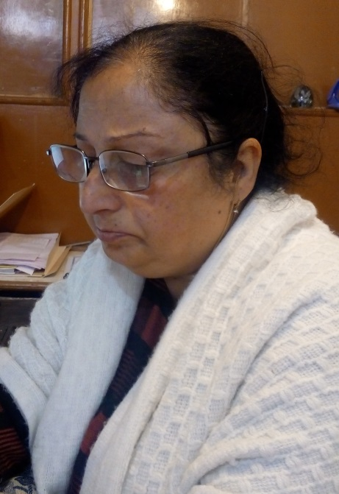

Mr. Jan Mohd Baba

Sr. Technician

Physical Mett. Lab

Contact No. 9103139036

Mr. Gulzar Ahmad Sofi

Sr. Technician

Mech. Mett. Lab

Contact No. 9541130704

Mr. Hilal Ahmad Dar

Sr. Technician

Mineral Dressing Lab

Contact No. 9906479597

Mrs. SunitaDhar (Hak)

Sr. Assistant (Superintendent)

Office

Contact No. 9419355904